Paper Chain Practise Challenge!

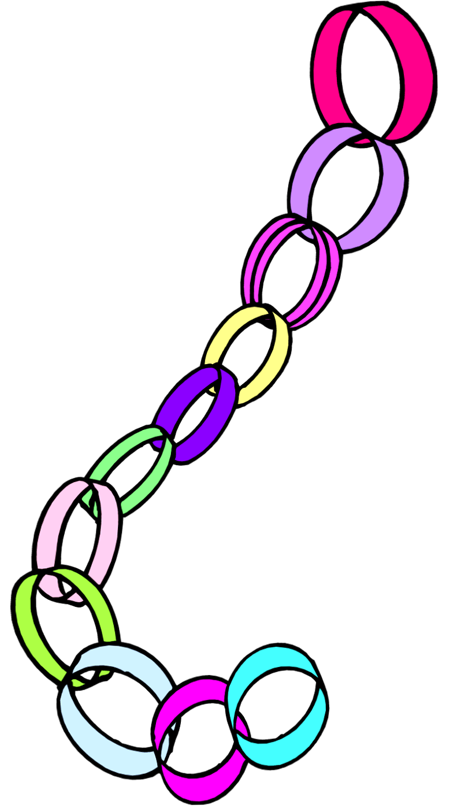

*For this Practise Challenge, you will need:*

1. A Violin!
2. Some coloured paper, cut into strips about 3cm

Wide OR some paper chain paper

1. Stickers
2. Glue/sticky tape
3. A pen

*How the Challenge works!*

1. Play your violin every day = add at least one link to the paper chain each time you practise.
2. Add an extra one for willingness
3. And positivity
4. And trying hard
5. And sticking at it
6. And reviewing pieces
7. And working to develop a particular technique or musical point –
8. And listening to the recordings

How many links can you get on your ‘Practise Challenge Chain’?

I am looking forward to hearing how it has helped you and how long the paper chain has got after the lockdown!

Happy practising!